Focus Area #4: Query for IIS Record

# Background Material

This focus area contains the primary use case and the focus for the meeting. All other focus areas support this one.

## Information for the Group

In order for the group to understand this section they will need to be familiar with:

* HL7 v2 query and response messages (QBP & RSP)
* CDA

This information for the group is not covered here in the background material.

## Most Basic Use Case

The core use case, which we are proposing for support from Meaningful Use certification involves getting the vaccination history for a single patient back to clinicians who are in the process of giving care to a patient. The goal of this use case is to ensure that the clinician has all the information necessary to determine if the patient needs to be vaccinated today. The most basic process is as follows:

1. Clinician using an EHR requests a vaccination record from the IIS.
2. The IIS finds the patient record, attaches a forecast and evaluation. If the record is not found, the IIS returns a not found message.
3. The IIS creates a response that includes the vaccination history and the recommendations and sends it back to the EHR.
4. The EHR displays the results to the clinician.

## Out of Scope Use Cases

These use cases are not being considered now but are being identified for future discussions:

* EHR is conducting reminder/recall activities.
* Quality Reporting or Population Health Management.
* IIS updates the EHR with changes to a patient record. (i.e. IIS sends EHR VXU messages.)
* Standards for connecting directly to a forecast engine to allow the EHR to get decision support.

### Comment

These use cases could be supported by standards, even by the standard that is selected. These are not being considered here because they are not central to the primary use case. Once the base standard is solidified, adopted and used, these use cases can be re-addressed to see how the current functionality supports these activities. The goal of this project is to focus on a critical goal, which if we are successful with, we can build support for other beneficial uses. Of course, IIS and EHRs can accomplish these use cases now, even without a unified national standard, and this can continue.

## Best Practice Use Case

The use case above meets the very basic minimum requirements but is not recommended as best practice as it does not account for the need to pull the data received back from the IIS and merge it with the patient’s record in the EHR system.

1. Clinician using an EHR requests vaccination record from IIS in preparation for patient care.
2. IIS finds the patient record. If not found, IIS returns not found message.
3. IIS creates evaluation and forecast and appends to record.
4. IIS puts the data in a format that the EHR can use and sends it to the EHR.
5. If applicable, the EHR processes the immunization and forecast data from the IIS.
6. The EHR displays the patient record in the EHR.

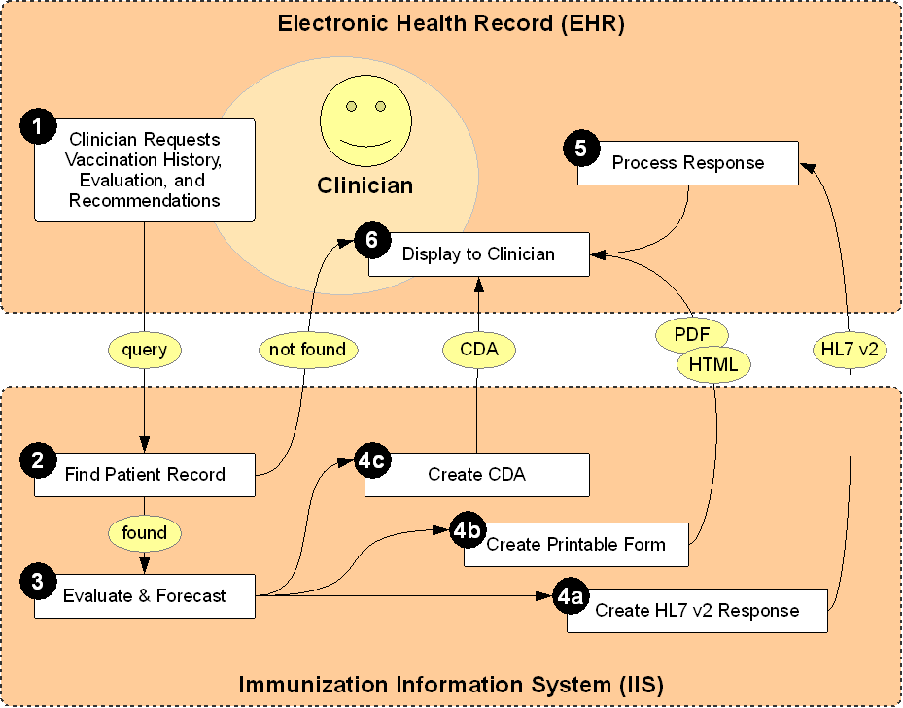

## Variation Using Same Best Practice Use Case

The best practice use case imagines a clinician requesting the patient record with the patient present. The following variations differ only by the reason for the query, but must be considered as query interfaces have often been used this way:

* EHR automatically requests an updated vaccination record for all patients scheduled for certain, selected appointments. For example, when a patient is scheduled for a well child visit, the EHR automatically requests the latest vaccination record from the IIS.
* EHR requests updates for all patients or a large subset of patients.

### Decision Point

|  |  |  |  |
| --- | --- | --- | --- |
|  | Recommend | Permit | Discourage |
| Clinicians query IIS during patient encounter. |  |  |  |
| Clinicians query IIS in preparation for patient encounter. |  |  |  |
| EHR automatically queries IIS when patient is scheduled for a specific type of visit. |  |  |  |
| EHR automatically queries IIS when patient is scheduled for any visit. |  |  |  |
| Clinician initiates process to queries IIS for all patients or a large subset of patients. |  |  |  |

## Other Potential Use Cases

* Receiving and printing the official state school form or state immunization record.

### Comment on School Forms

Support for school forms and immunization records is important in some IIS. This is not the primary use case but this group could recommend the following:

* A new standard for getting printable forms be created. This standard may not be part of meaningful use certification but may be of value if states who do this would at least have a common standard.
* The standard beings selected now could be designed in such a way to support this use case.

At any rate, one of the comments about this area was made that printing out school forms is a bit backwards and should be done less in the future. The whole reason why we have IIS is so that it contains the official immunization record. Schools should be getting access to the IIS to get those records directly and not be looking for a printed record to hand-enter into their own system. So this standard may be important now, but maybe it’s use has a limited lifetime as we move towards a paper-less world.

## Patient Matching

This use case assumes that the EHR has some type of unique id in common with the IIS and is able to either get a single good match back or no match. The use case for managing this unique id is covered in Focus Area #3. For purposes of discussion here, assume that patient matching has either completed and a match is known or is not possible because the patient record is not in the IIS.

## Manual vs Unattended

EHR systems take one or two basic tactics towards querying the IIS:

* EHR involves the user directly in the process of querying the IIS.
* The EHR queries the IIS using a background process. The user may initiate the process and can check the status of the process but is not directly involved.

## Format of Patient Record

The data being sent back to the EHR can be in different formats:

* HL7 v2 RSP format. This is the format currently supported by many IIS.
* Image or printable format such as JPEG or PDF. This is used to support printing school forms or official state immunization forms.
* CDA. This is a new standard but could combine the benefits of both RSP format and the printable format.

### Benefits and Drawbacks

|  |  |  |
| --- | --- | --- |
|  | Benefits | Drawbacks |
| HL7 v2 RSP | * Well established standard. * Currently supported by many IIS and EHR. * Supports proposed use case very well. | * Requires EHR to properly parse and process data. |
| Image or printable document | * Simple to implement for EHR systems. * Supports school enrollment. * IIS has full control of display format | * Does not allow EHR to read data or use it. * Only supports a set of narrow use cases and nothing else. |
| CDA | * Standard is being widely adopted by EHRs. * Allows IIS to control display layout and format. * EHRs can support simple use cases very simply. * EHRs can pull data out easily and support more complicated use cases. | * Some work is needed to create a specific CDA document. * Has not yet been implemented by IIS. |

### Future Standards

The idea behind adopting CDA is to move forward now to adopt a standard that is being used more and more. Perhaps the IIS community should move towards this standard now, rather than delaying.

The other idea that was floated was that HL7 is working on a new standard call Fast Healthcare Interoperability Resources (FHIR) that is quite exciting and may have potential use in the IIS community. FHIR solves a lot of the problems we have been dealing with in HL7 v2 and is much easier to implement than HL7 v3. But the standard is still very new and won’t be ready for use for another year or so. So we did not consider FHIR in preparation for this meeting. Perhaps the best choice is to stay with the standard we know works for now until we have a clearer view of the future. Of course, predictions are very hard to make, especially about the future. ☺

### Decision Point

|  |  |  |  |
| --- | --- | --- | --- |
|  | Recommend | Permit | Discourage |
| HL7 v2 RSP |  |  |  |
| Image or printable document |  |  |  |
| CDA |  |  |  |

## EHR Support

The data received back by the EHR can be treated in different ways. The following different ways have been observed:

* Display the IIS vaccination record as-is to the clinician.
* Store the IIS vaccination record as-is for later viewing by the clinician.
* Display the data from the IIS vaccination record next to the data in the EHR.
* Merge the data from the IIS and EHR for display only.
* Store the data from the IIS but do not automatically merge with EHR record.
* Allow clinician to merge specific data from IIS into the patient’s EHR record.
* Merge the data from the IIS directly into the EHR patient record automatically.

### Decision Point

|  |  |  |  |
| --- | --- | --- | --- |
|  | Recommend | Permit | Discourage |
| Display the IIS vaccination record as-is to the clinician. |  |  |  |
| Store the IIS vaccination record as-is for later viewing by the clinician. |  |  |  |
| Display the data from both the EHR and IIS so that individual fields can be easily compared. |  |  |  |
| EHR can automatically read the data and store the individual information in a place reserved only for IIS data. |  |  |  |
| Clinician should be able to review differences between IIS and EHR record and select specific vaccinations to transfer to the EHR. |  |  |  |
| EHR should automatically update EHR record with updates from the IIS. |  |  |  |

## Patient Demographic Data

The IIS returns patient demographic data to the EHR. There can be different levels of completeness of this data:

* IIS may return the entire patient demographic record as it is officially recorded in the IIS.
* The IIS may return a very limited amount of demographic data.
* The IIS may return a hybrid of limited amount of demographic data or additional detailed information that was submitted by the EHR making the query.

The EHR has two options when receiving patient demographic data:

* Only display the demographic data from the IIS, but do not merge with current record.
* Allow some of the data fields to merged into the EHR patient record.

### Decision Point

|  |  |  |  |
| --- | --- | --- | --- |
|  | Recommend | Permit | Discourage |
| IIS should return a complete demographic record. |  |  |  |
| IIS should return a limited demographic record. |  |  |  |
| IIS may return all data originally submitted by querying system. |  |  |  |
| EHR should allow the user to see the demographic information returned by the IIS. |  |  |  |
| EHR should merge the demographic information into the patient record. |  |  |  |

## EHR Interpretation

One of the issues that needs to be addressed is that if the EHR is required to parse and read an HL7 response, this opens up the potential for several issues:

* The EHR may misread the IIS record, examples include:
  + EHR is reads a ‘998’ placeholder record as an actual immunization.
  + EHR reads delete or not administered vaccinations as administered.
* The EHR may not recognize duplicates because the vaccine code sent by the IIS does not exactly match the one stored in the EHR.
* The EHR may store the information in the wrong place in the EHR. (For example one EHR implemented their interface to store immunizations from the IIS as administered vaccinations in their system. These were later reported to the IIS as being administered.)
* The EHR user may delete duplicate vaccinations and these deletes may be sent back to the IIS who does not have duplicates. The IIS then deletes the vaccination from the official record.

### Assignment

How can the IIS community help EHR vendors to correctly process incoming messages? We know that some EHR’s have successfully done so, but there are many others that are new to this area and could make mistakes. How do we setup up the process so these mistakes can be prevented?

# Artifacts Needed

For the purposes of discussion the group needs to create the following items:

* Use case story(ies)
* Use case diagram(s)
* Lessons learned
* Decision points
* Recommendations
* Known needs
* Next steps

## Use Case Story

A use case story is a list of steps taken by a user and the interaction of systems to achieve a specific goal. The goal of this focus area is to select a single use case but other use cases stories should be written as well if they are to be discussed in detail.

## Use Case Diagram

Diagrams give a visual map to the story. Every use case story must have a corresponding diagram.

## Lessons Learned

Past experience helps when making future plans. Gather information about lessons learned when implementing query support. Be sure to include lessons learned from both the IIS and the EHR perspective.

## Decision Points

What are areas that need to be decided by the group? What are the options? What are the benefits and risks with each option?

## Recommendation

What is the recommendation of the group for each decision point? If the group is divided then list the two or three top recommendations.

## Known Needs

For each recommendation, list what support or help the EHR and IIS will need in order to meet the recommendation.

## Next Steps

For each recommendation, list the next steps that will need to be taken.